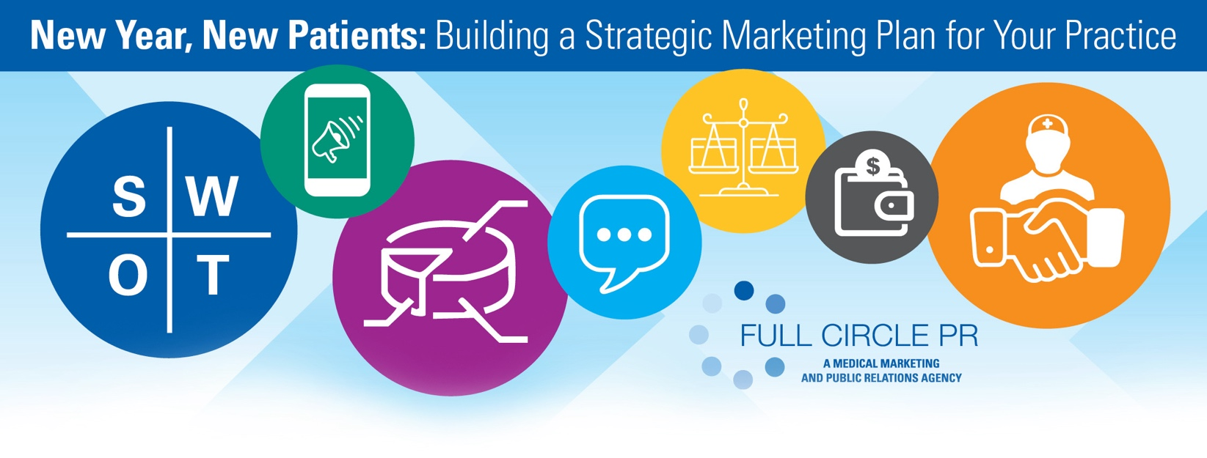

The new year is an ideal time for medical practices to evaluate and update their marketing strategies, ensuring they effectively reach patients, expand referral networks, and enhance their reputation in the healthcare community. This guide outlines essential steps to develop a comprehensive marketing plan.

**1. Conduct a SWOT Analysis**

A **SWOT Analysis** (assessing **Strengths, Weaknesses, Opportunities,** and **Threats**) can help practices clarify their strategic direction. It highlights internal strengths to leverage, weaknesses to address, and external opportunities and threats that may impact success. This initial evaluation ensures that marketing efforts align with both the practice’s capabilities and market needs.

**2. Competitive Analysis**

A thorough **Competitive Analysis** helps identify what similar practices offer, where they succeed, and where there’s room for differentiation. This includes evaluating competitors’ digital presence, community involvement, and unique service offerings. Understanding the competitive landscape provides valuable insights that can inform marketing efforts and highlight areas where a practice can stand out.

**3. Market Analysis**

Analyzing local market demand and patient demographics enables practices to tailor their services to community needs. A **Market Analysis** includes looking at population trends, age demographics, and health concerns prevalent in the area. This data helps practices prioritize services and outreach to meet the most pressing needs in their community.

**4. Clear and Consistent Messaging**

A clear, compelling message that conveys a practice’s unique values—such as a commitment to patient-centered care or expertise in specialized treatments—strengthens brand identity. Consistent messaging across all marketing materials creates a cohesive brand presence that resonates with patients and builds trust.

**5. Customer Service as Marketing**

An exceptional **Patient Experience** can be one of the most effective marketing tools. Since the majority of patient dissatisfaction often relates to service rather than care quality, focusing on improving the patient journey is key. Practices can enhance the patient experience through efficient phone systems, friendly in-office interactions, and proactive follow-up communication. Prioritizing these elements fosters patient loyalty and encourages positive word-of-mouth.

**6. Budget Planning**

Budgeting appropriately for marketing is essential. The U.S. Small Business Administration suggests that established practices allocate around 7-8% of gross revenue toward marketing, while new practices may benefit from setting aside 11-13% due to the higher costs associated with establishing brand presence in competitive markets​. Allocating these funds across digital, traditional, and community channels can provide a well-rounded approach to patient engagement and outreach.

**7. Digital Engagement**

Effective **Digital Engagement** through social media, e-newsletters, and online review management helps build patient trust and encourages ongoing engagement. Social media platforms, such as Facebook and Instagram, offer valuable opportunities to share educational content, patient success stories, and practice updates, while e-newsletters keep patients informed on relevant health topics and practice news.

**8. The Role of a Physician Liaison**

A **Physician Liaison** serves as a critical link between a practice and external providers, helping to increase referrals, foster relationships with other healthcare facilities, and expand patient access to services. The liaison’s role includes promoting the practice’s services, gathering feedback from referral sources, and participating in community outreach to build the practice’s visibility.

**Supporting Your Marketing Goals** A well-rounded marketing plan that includes strategic analysis, competitive insights, clear messaging, digital engagement, and strong community relationships lays a strong foundation for growth. Practices seeking expertise in healthcare marketing may find additional support in Full Circle PR, a specialized agency providing services in competitive analysis, branding, digital marketing, and community outreach to enhance patient engagement and practice growth.

[Info@FullCircle-PR.com](mailto:Info@FullCircle-PR.com), 813-887-3277